

CS 431-01 Phase II

Employees by Industry Based on Payroll (All Industries)



September 21, 2017

John Carlo agahan, erin bryce duenas, rush adams, marco rubio, gabrielle aguIlar

Group 1

**Instructions**

1. Using the given data, write an assembly program to analyze the data and predict the future 3 years of the Employees by Industry Based on Payroll from 2009-2017.
2. Use the Non-Linear Regression Method with the formula, Y = Ax2 + Bx +C, where Y is the Employees for the predicted year of X to solve for A and B and C.

**Introduction**

For our project we decided, as a group, to go with *Employees by Industry Based on Payrolls on Guam* with a focus on Construction employees from years 2009 – 2014. Each year, the data was broken up into four quarters of the year which recorded jobs in March, June, September, and December. Our objective for this project is to see how many more jobs will there be in the four quarters of the next three years from 2015-2017.

**Requirements**

Microsoft Office Excel

Guam Statistical Yearbook 2014

Dr. Java

Google Docs

*Software Engineering* by Kassen A. Saleh, J. Ross Publishing @2009

*Object-Oriented and Classical Software Engineering*, 6th ed. By Stephen R. Schach

**Specification**

Each group member of Group 1 is expected to perform their own calculations of the future predictions to compare to see if everyone is using the correct formuals and getting the same outputs of information. After this initial phase of data analysis by hand, each group member will be tasked with creating a program to calculate all the formulas. As a group, we will help each other in this process by debugging and comparing the program results with the hand-calculated results to see if the program works as intended. We will communicate with each other via e-mail and occassionally have group meetings inside and outside of class.

**Initial Data**

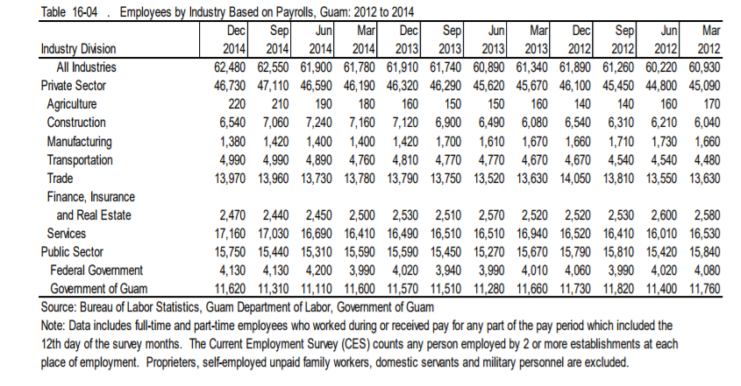

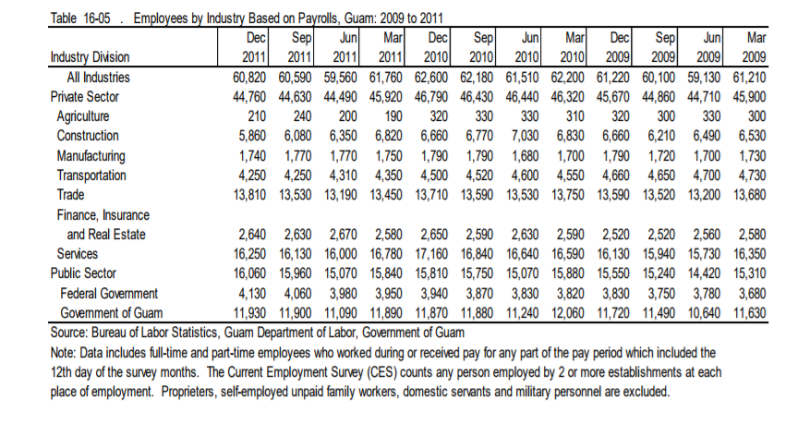

**Table & Graph 1: Initial Data Excel Spreadsheet**

We took our initial data and created a scatter plot on Microsoft Excel. We then used the Excel program to show a linear and logarithmic trend line based on the data. From this, we were able to see that both trend lines were ovelapping.

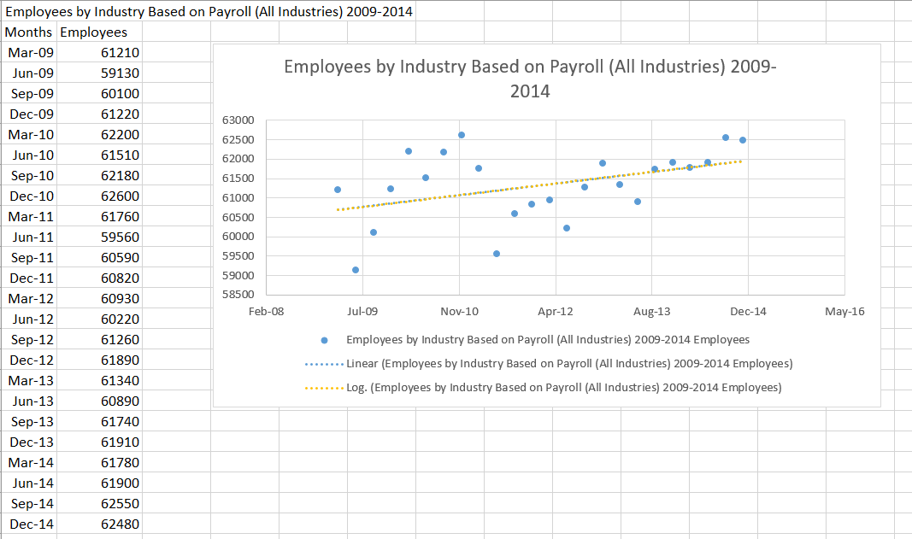

**Table 2: Given Formulas for Non-Linear Regression**

|  |  |
| --- | --- |
| **Variable Name** | **Equation** |
| **M11** | $$\sum_{i=1}^{n}{X_{i}^{4}}$$ |
| **M12** | $$\sum_{i=1}^{n}{X_{i}^{3}}$$ |
| **M13** | $$\sum_{i=1}^{n}{X_{i}^{2}}$$ |
| **M14** | $$\sum_{i=1}^{n}{Y_{i}}X_{i}^{2}$$ |
| **M21** | $$\sum_{i=1}^{n}{x_{i}^{3}}$$ |
| **M22** | $$\sum_{i=1}^{n}{X_{i}^{2}}$$ |
| **M23** | $$\sum_{i=1}^{n}{X_{i}^{}}$$ |
| **M24** | $$\sum_{i=1}^{n}{Y_{i}}X_{i}^{}$$ |
| **M31** | $$\sum_{i=1}^{n}{X_{i}^{2}}$$ |
| **M32** | $$\sum_{i=1}^{n}{X_{i}^{}}$$ |
| **M33** | $$\sum_{i=1}^{n}{1=n}$$ |
| **M34** | $$\sum_{i=1}^{n}{Y_{i}^{}}$$ |
| **L** | **(M11*M22*M33)+(M12*M23*M31)+(M13*M21*M32)-(M13*M22*M31)-(M11*M23*M32)-(M12*M21*M33)** |
| **L1** | **(M14*M22*M33)+(M12*M23*34)+(M13*M32*M24)-(M13*M22*M34)-(M23*M32*M14)-(M33*M24*M12)** |
| **L2** | **(M11*M24*M33)+(M14*M23*M31)+(M13*M34*M21)-(M13*M24*M31)-(M23*M34*M11)-(M33*M21*M14)** |
| **L3** | **(M11*M22*M34)+(M12*M24*M31)+(M14*M32*21)-(M14*M22*M31)-(M24*M32*M11)-(M34*M21*M12)** |
| **A** | **L1 / L** |
| **B** | **L2 / L** |
| **C** | **L3/L** |

**Table 3: Output Values**

|  |  |
| --- | --- |
| **Variable Name** | **Equation** |
| **M11** | **1763020** |
| **M12** | **90000** |
| **M13** | **4900** |
| **M14** | **32837870** |
| **M21** | **90000** |
| **M22** | **4900** |
| **M23** | **300** |
| **M24** | **1991270** |
| **M31** | **4900** |
| **M32** | **300** |
| **M33** | **24** |
| **M34** | **157980** |
| **L** | **1210352000** |
| **L1** | **4709112000** |
| **L2** | **-100340830400** |
| **L3** | **8259958720000** |
| **A** | **3.89069626** |
| **B** | **-82.902189** |
| **C** | **6824.426877** |

**Table 4: Predicting the Future the Next 3 years of Employees by Industry Based on Payroll (Construction)**

|  |  |  |
| --- | --- | --- |
| **Month-Year** | **Slope Y(x) = Ax2 + Bx + C** | **Prediction For Employees (rounded to whole number)** |
| Mar-15 | Y(25)=( **3.89069626**)(25)2 -**82.902189**(25)+ **6824.426877** | 7184 |
| Jun-15 | Y(26)=( **3.89069626**)(26)2 -**82.902189**(26)+ **6824.426877** | 7299 |
| Sep-15 | Y(27)=( **3.89069626**)(27)2 -**82.902189**(27)+ **6824.426877** | 7422 |
| Dec-15 | Y(28)=( **3.89069626**)(28)2 -**82.902189**(28)+ **6824.426877** | 7553 |
| Mar-16 | Y(29)=( **3.89069626**)(29)2 -**82.902189**(29)+ **6824.426877** | 7692 |
| Jun-16 | Y(30)=( **3.89069626**)(30)2 -**82.902189**(30)+ **6824.426877** | 7839 |
| Sep-16 | Y(31)=( **3.89069626**)(31)2 -**82.902189**(31)+ **6824.426877** | 7993 |
| Dec-16 | Y(32)=( **3.89069626**)(32)2 -**82.902189**(32)+ **6824.426877** | 8156 |
| Mar-17 | Y(33)=( **3.89069626**)(33)2 -**82.902189**(33)+ **6824.426877** | 8326 |
| Jun-17 | Y(34)=( **3.89069626**)(34)2 -**82.902189**(34+ **6824.426877** | 8503 |
| Sep-17 | Y(35)=( **3.89069626**)(35)2 -**82.902189**(35)+ **6824.426877** | 8689 |
| Dec-17 | Y(36)=( **3.89069626**)(36)2 -**82.902189**(36)+ **6824.426877** | 8882 |

**Graph 2: Non-Linear Regression Line for Employees by Industry Based on Payroll (Construction) 2009-2017**

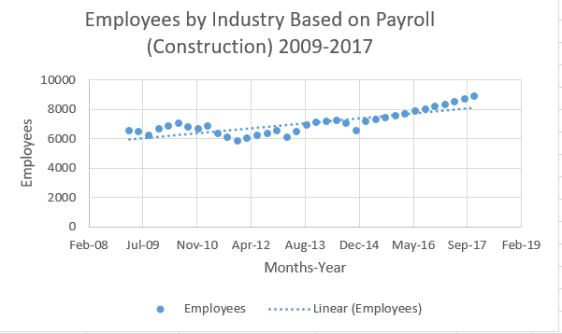

**Graph 3: Non-Linear Regression Line for Employees by Industry Based on Payroll (Agriculture) 2009-2017**

**Graph 4: Non-Linear Regression Line for Employees by Industry Based on Payroll (Manufacturing) 2009-2017**

**Graph 5: Non-Linear Regression Line for Employees by Industry Based on Payroll (Transportation) 2009-2017**

**Graph 6: Non-Linear Regression Line for Employees by Industry Based on Payroll (Trade) 2009-2017**

**Graph 7: Non-Linear Regression Line for Employees by Industry Based on Payroll (Finance, Insurance, and Real Estate) 2009-2017**

**Graph 8: Non-Linear Regression Line for Employees by Industry Based on Payroll (Services) 2009-2017**

**Graph 9: Non-Linear Regression Line for Employees by Industry Based on Payroll (Federal Government) 2009-2017**

**Graph 10: Non-Linear Regression Line for Employees by Industry Based on Payroll (Government of Guam) 2009-2017**

**Conclusion**

In conclusion, by predicting the next 3 years of *employees in the construction field*, we were able to see that there will be an increase in jobs. Our use of Microsoft Excel to plot our calculated data and predictions shown in the graph above is proof that there will continue to be an increase in jobs even pass our initial prediction years of 2009-2017. The only thing that could affect this prediction of jobs is if some extraordinary circumstance affects the construction industry on Guam.

**Acknowledgements/References**

*Guam Statistical Yearbook 2014.* Guam: Bureau of Statistics and Plans Office of the Governor of Guam, 2015. Print.